M_version (left-handed)

Thank you for participating in this study!

You will see a room with a man inside.
On the left and right walls, there are sometimes red circles pinned on the wall.
Here is an example:

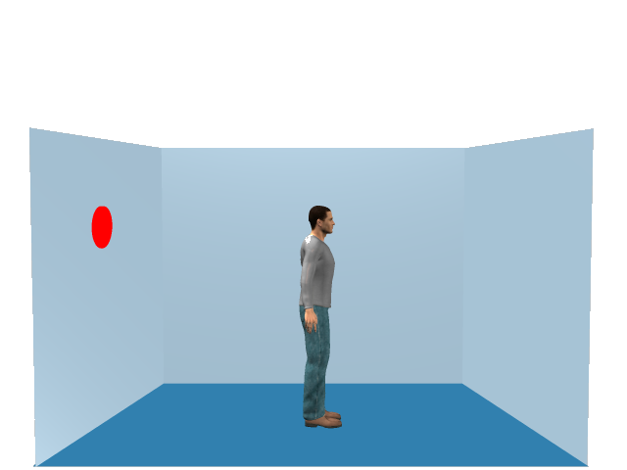

On half of the trials, I will ask you to verify if a given number corresponds to how many circles you can see from your perspective.
On the other half of the trials, I will ask you to verify if a given number corresponds to how many circles the man can see from his perspective.

Concretely during the experiment you will see the following sequence of events:

(1) a fixation cross in the centre of the screen, then
(2) the word YOU or HE telling you which perspective you will have to verify, then
(3) a number between 0 and 3 telling the amount of circles to verify (sometimes the amount will match the perspective and sometimes not), then
(4) the picture of the room will appear, as soon as you see the picture if will ask you to tell if yes or no the number of circles announced before (3) corresponds to the number of circles seen from the announced perspective (2):

If the number of circles matches the perspective press the RIGHT button mouse with your INDEX finger,
If the number of circles doesn’t match the perspective press the LEFT button mouse with your MIDDLE finger.

(5) After your response, you will be given a feedback (“Correct” or “Wrong”)

It is important that you try to respond as quickly and accurately as possible.

On the following page you can see 2 examples.

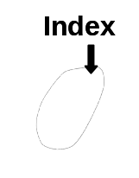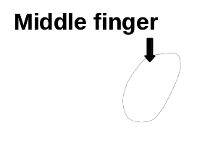
+
YOU
1
Correct
+
HE
1
Correct
We will start with a practice block.

Then, there will be 4 test blocks.

In between the blocks, you can take a break.

As a reminder, try to respond as quickly and accurately as possible.

Thanks again for your participation!

